CHAPTER 5: Chemical reactions
Worksheet 5.5

Metal displacement
Student: Class:

Growing metal crystals
1. A shiny copper wire was suspended in a test tube containing a solution of silver nitrate. Over time, shiny silvery coloured crystals grew on the surface of the copper wire. The experiment was repeated with a shiny magnesium wire in place of the copper wire. Once again silvery crystals grew on the wire surface. However, the crystals grew at a faster rate.
(a) Identify the silvery crystals that formed in each experiment.

(b) Write word equations for each reaction.

(c) Explain why the crystals grew faster in the second experiment.

The activity series of metals
2. The following table shows the activity series of metals.

Li | K | Na | Ca | Mg | Al | Mn | Cr | Zn | Fe | Ni | Sn | Pb | H | Cu | Hg | Ag | Au | Pt

The photo shows zinc reacting with hydrochloric acid.
 | 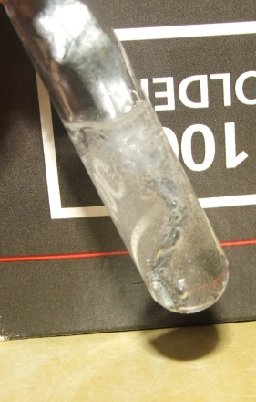  Photo: Public domain | (a) Identify the gas released in the reaction.  (b) Write a word equation for the reaction.  (c) Explain why this reaction is an example of a  displacement reaction.  (d) Use the activity series to identify:  (i) metals that will not react with hydrochloric acid  (ii) the metal that will react most rapidly with the  acid solution.

